Final Assessment-Alternative Assessment
Semester | 202520 | Division | CIS
Assessment title in Syllabus | Final_Project_Portfolio | Program | Bachelor of Information Technology/ Bachelor of Information Systems
Course Code | CDS 2413
Course Title | INTRODUCTION TO DATA SCIENCE
Course Instructor |  | CRN
Assessment | Project Deliverable 1 – Data Analysis Report | Submission Date | Week 6
Student Declaration:
Academic Integrity Statement
In accordance with the HCT Academic Integrity Policy
• Students are required to refrain from all forms of academic integrity breaches as defined and explained by HCT.
• A student found guilty of having committed acts of academic integrity breach(es) will be subject to the relevant sanctions as outlined by HCT.
إفادة النزاهة الأكاديمية
وفقًا لسياسة كليات التقنية العليا للنزاهة الأكاديمية
• على الطلبة الإلتزام بلوائح وقواعد النزاهة الأكاديمية، كما هو مبيّن وموضح في السياسات والإجراءات الخاصة بكليات التقنية العليا.
• في حالة ارتكاب الطالب أي شكل من أشكال الإخلال بالنزاهة الأكاديمية، سيتعرض الى العقوبات الموضحة في السياسات ذات الصلة.
This assignment is entirely my/our own work except where I have duly acknowledged other sources in the text and listed those sources at the end of the assignment. I have not previously submitted this work to the HCT, or any other entity. I understand that I may be orally examined on my submission.

Student HCT ID(s): | H00566186 | H00494267 | H00494267 | H00
Student Name(s): | Easa Abdulaziz | Ahmed saeed | Hamza Fahmi
Student Signature | -E | -A | -H
Chatbot (e.g. ChatGPT) statement
This submission allows you to use AI generated tools, but the prompt used must be stated and the response must be in red font. Include References to ChatGPT.

Instructions

Remove instructions and hints from the template before submitting the final report to BBLearn.

CLO1: Introduction and Data Wrangling (5 Points)

Purpose of Data Analysis (1 point)
<< Define the purpose of data analysis for the chosen dataset >>.
Answer:

This analysis will examine the various trends concerning both the quantitative and qualitative data (study habits, school involvement, motivation level, and parental involvement), highlighting the intricacies surrounding academic achievement based on the variables.

The end aim of this study is to provide educators with better insight on how they can make better use of the information acquired from these results and improve student academic strategies for better academic success.

Type of Programming (1 point)
<< Identify and Justify the type of programming used for data analysis.>>
Answer:

The use of data analysis in this project via the use of Python programming makes it easy to find, process, and represent Data.

The tools provided by the Python libraries "Pandas," "NumPy," and "Matplotlib," provide the means to accurately and clearly present data and will be used throughout this research project.

Using Python as a means to facilitate data analysis also makes Python a viable and reliable option for performing Data Analysis throughout the duration of this project.

Type and Purpose of ML algorithm (1 point)
<< Identify the type and purpose of the machine learning algorithm to be implemented for the chosen dataset >>
Answer:

In this study, a regression-based machine learning algorithm will be employed.
This is appropriate because the data set has numerical values that describe student academic performance.

The main goal of using the regression algorithm is to identify the relationship between the independent variables, such as study habits and study engagement, and the dependent variable, which in this case is academic performance.
Moreover, the regression algorithm will enable the model to predict academic performance using the given variables.

Identify the Varaibles (1 point)
<< Identify and Justify the independent and dependent variables for the chosen dataset.>>
Answer:

The dependent variable in this dataset is academic performance, which is the students’ academic results and the key variable for analysis.

The independent variable is study habits, which is the students’ level of engagement in academics and is expected to affect the students’ academic performance.

These variables are chosen because study habits can directly affect the students’ academic performance and thus can be analyzed.

Sampling (1 point)
<< Will you do the sampling? Identify and Justify the type of sampling to be used for the chosen dataset.>>
Answer:

Yes, the process of sampling will be employed in this research study, and a sample of the data set will be analyzed.

Random sampling will be employed in this research study to ensure that the data is chosen without any bias.

Systematic sampling will also be employed in this research study to ensure that the data is chosen in a structured manner. These methods will be employed to reduce bias and make the process of data analysis efficient.

CLO2: Descriptive, Exploratory and Statistical Analysis (10 Points)

Purpose of Descriptive Analysis (1 point)
<< Justify why you want to perform the descriptive analysis for the chosen dataset. >>.
Answer:

Descriptive analysis is carried out to identify and understand the overall characteristics of the dataset.
It is also helpful in identifying patterns, trends, and distribution of students’ academic performance.

In addition, descriptive analysis is also helpful in identifying outliers and variations in the data, which is required before performing further tests and predictive analysis.

Script for Descriptive Analysis (1 point)

<< Create a script to develop a Python function for descriptive statistics. The input for the function should be the sample and the field to perform the descriptive statistics..>>
Answer: 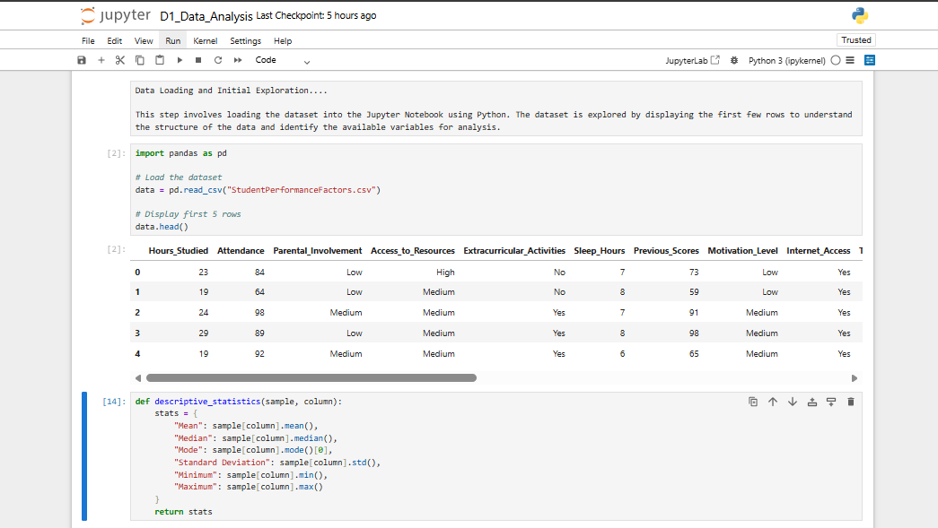
Explaination:

The Python function is built and designed to compute a variety of statistical values concerning a chosen variable from the dataset.

The dependent variable in this analysis is Previous_Scores, and the independent variables could be any variable from the dataset, for instance, Hours_Studied, Attendance, Motivation_Level, and so forth.

The Python function works actually by receiving a sample and a chosen variable from the dataset and determining the respective mean, median, mode, standard deviation, and other values.

Random Sampling (1 point)
<< Create a program to random sampling of size 150 and find the descriptive statistics for the dependent variable from the sample [Apply the descriptive function which you created].>>
Answer:

A random sample of 150 data records has been taken from the data set, which represents the population in an unbiased manner.

The function of descriptive statistics has been applied to the dependent variable, which gives an idea about the important aspects of the data, i.e., mean, median, standard deviation, lowest value, and highest value, which describe the academic performance in the sample data.
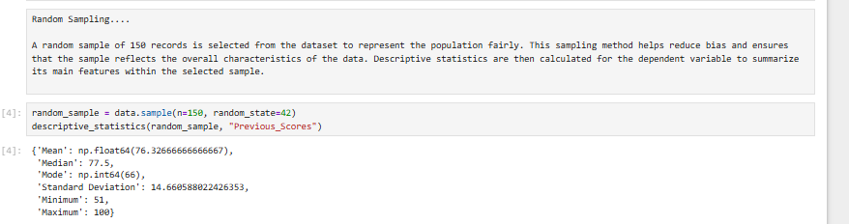

Systematic Sampling (1 point)
<< Create a script for systematic sampling by giving certain conditions and finding the desc stat for the dependent variable from the sample [Apply the descriptive function which you created]..>>
Answer:

In systematic sampling, every 5th value is selected from the dataset, thus creating a structured sample. This ensures that the data is selected at regular intervals. Finally, the descriptive statistics function was used on the dependent variable to describe its essential characteristics.

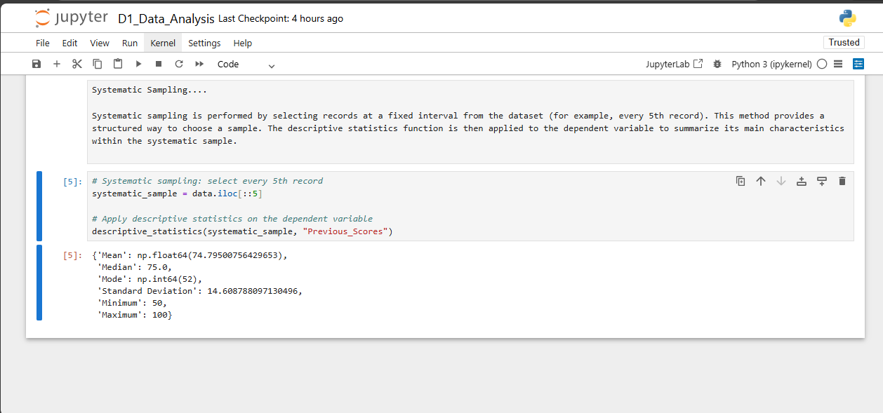

Descriptive Statistical Report (1 point)
<< Create a detailed descriptive statistics report about the dependent variable of the chosen dataset.>>
Answer:

The descriptive statistics of the dependent variable indicate that the students’ performance is moderately positioned.

The mean and median are close to each other, and this shows that the data is relatively balanced without any skewness.

The standard deviation shows that the variation in the students’ performance is reasonable. Moreover, the minimum and maximum values show that there is a wide range of scores, and this indicates the variation in the students’ performance.

Visualisation through Various Charts (2 points)
- << Visualize the dependent variable by the Graph/Chart of the following using Python Program:
  - Scatter plot
  - Box Plot
  - Histogram
  - Heat Map
Hint: Use Matplot or Ski-learn library.>>
A.Scatter plot. 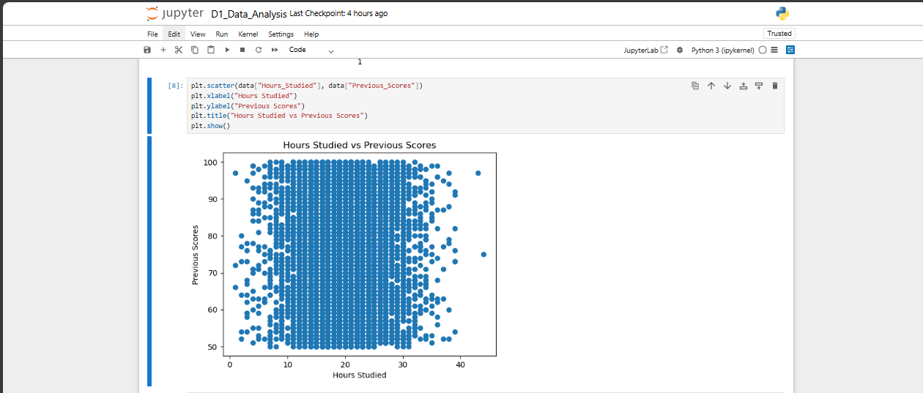
Scatter Plot – Explanation:

The scatter plot represents the relationship between the independent variable and the dependent variable. The points seem to be scattered randomly without any particular pattern, which indicates that there is a weak relationship between the variables.

B.Box Plot. 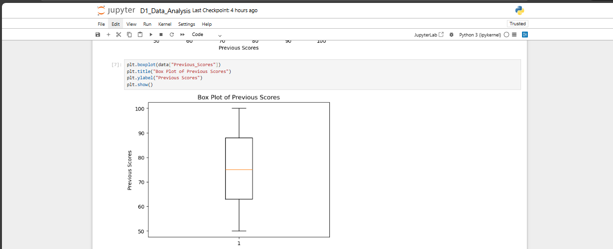
Box Plot – Explanation:

The box plot helps to understand the distribution of the data and also points out the possible presence of outliers. The interquartile range indicates the middle 50% of the data, and the whiskers indicate the total range. The fact that there are no extreme outliers indicates that the data is quite consistent.

C.Histogram.
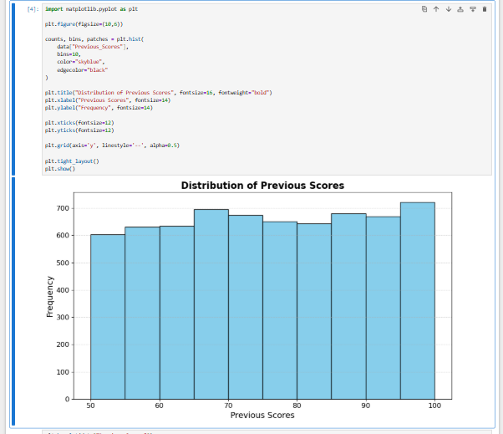
Histogram – Explanation:

The histogram reveals the spread of the dependent variable. The data seems to be scattered evenly across the range without being too concentrated in a particular area. This suggests that the previous scores of students are moderately varied.

D.Heat Map.
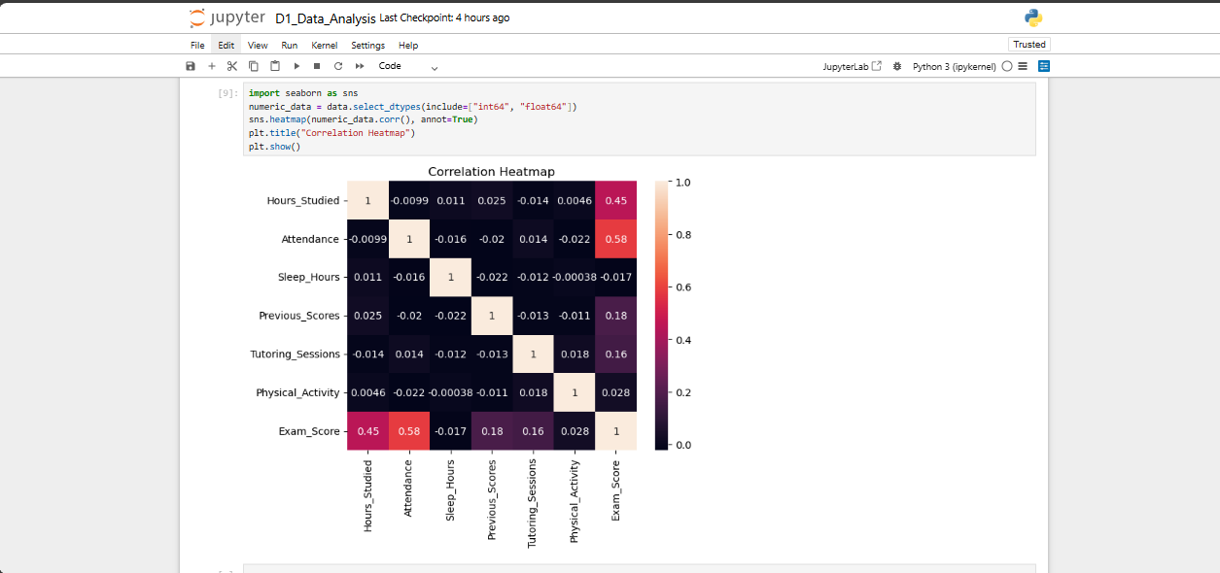
Heatmap – Explanation:

The heatmap shows the correlation between the numerical variables in the dataset. The intensity of the color represents the strength of the correlation. It seems that most of the correlations are weak to moderate, which means that no variable has a strong influence on academic performance.

Visualization Analysis-Explaination:

The visualizations help to have a better understanding of the data. The histogram helps to understand the distribution of the dependent variable among the students.

The box plot helps to understand the variability of the data. It also helps to understand if there are any extreme values or outliers in the data.

The scatter plot helps to understand the relationship between the independent variable and the dependent variable. It helps to understand if there is any trend or pattern in the data. Finally, the heatmap helps to understand the correlation between the numerical variables. It helps to understand the relationship between the variables in the data.

Hypothesis Test (1 point)
<< 8. Perform the hypothesis test to find the correlation (Pearson and Spearman for numerical variable and chi-square test for categorical variable) between the independent variable and the dependent variable.
Note: If you have more than one independent variable, then choose any one of the independent variables..>>
Answer:

The results reveal that the correlation between the hours of study and the previous academic scores is very weak.

This shows that the hours of study might not have a significant effect on the academic performance, and other factors might also have an important role to play.
Pearson ≈ 0.025
Spearman ≈ 0.024
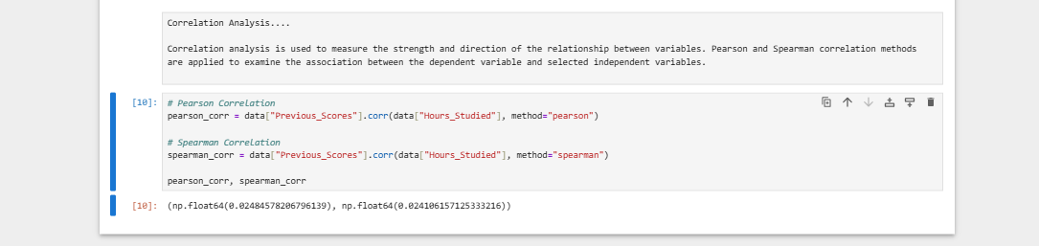
Answer:

The Pearson correlation test and Spearman correlation test were employed to determine the relationship that exists between the dependent variable and the selected independent variable.

The Pearson correlation test determines the extent of the relationship, while Spearman correlation determines the relationship using ranked values.

The results show a very weak relationship, implying that the selected independent variable does not influence academic performance.

One Sample T-test (2 points)
<< Assess the performance of the dependent variable to know whether the sample is representative of the normal population by a one-sample t-test..>>
Answer:

A one-sample t-test was used for comparing the mean of the dependent variable with the hypothesized value.

Based on the value obtained from the test, the results enable the assessment of whether there is a statistically significant difference between the sample mean and the assumed average value, with the aim of evaluating the academic performance of students in relation to the assumed value.

Based on the p-value obtained, the test indicates whether the sample mean is significantly different from the hypothesized value.

p-value < 0.05
p-value ≥ 0.05

A p-value less than 0.05 means that the result is statistically significant.
A p-value equal to or greater than 0.05 means that the result is not statistically significant.
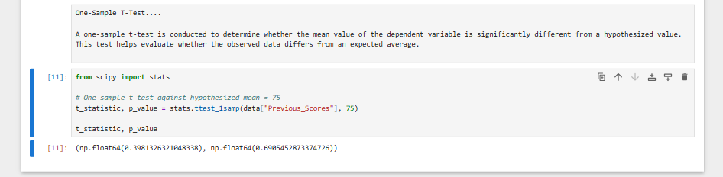

End of Documentation.

